2018

5/1/2018

OOP Pharmacy Project

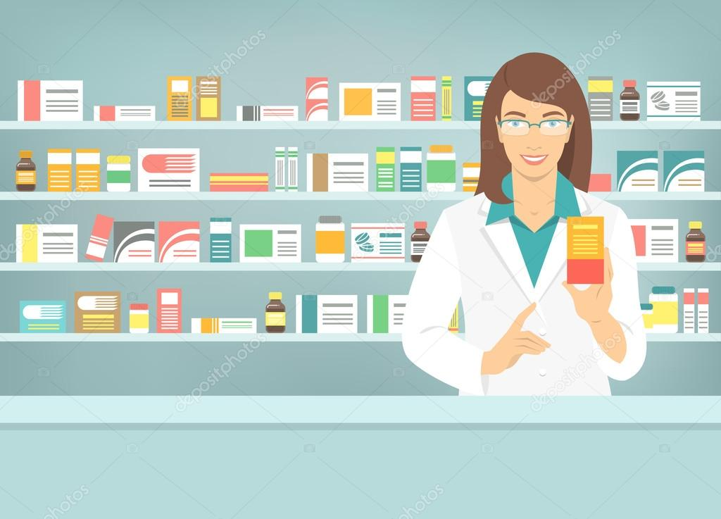

**Project Team Members:**

1. Mohamed Shawky Ahmed Mohamed Sec: 10 .
2. Mazen Sabry Hammam Sec: 9.
3. Mohamed Adel Zaki Elbaal Sec: 11.
4. Mohamed Khaled Elsayed Mohamed Sec:10.
5. Amira Ahmed Mostafa Ghanem Sec:4.
6. Mohamed Abdel Nasser Mohamed Abdou Sec:11.

**Abstract:**

This new pharmacy management system is quite different from other pharmacy software. This pharmacy software has been built for team collaboration for the development team and all its members who will be a part of development team. It’s the user friendly software with customization feature that makes your work easier. As we all know, pharmacy management system is one of the most complex software to build and keep all consistent information to exist in this competitive market and this software having all feature which will meet your requirements.

**Objective:**

this pharmacy management system built for development sections, its features includes sharing of images and documents with your team members, share formulas, import and have quick look on important formulas, check status on going works, divide your development work in different modules to your group members and among all, it’s an online system which provides you the power to access from any location with proper authorization technique. Among many features, some more exciting features which has been added to make a professional software are: compatible for latest release operating systems, facilitation of storing data on central server and work locally, facility of using any DBMS software because of using ORM concept and in built modules for what you needed while your ongoing work.

**Illustrate of Project:**

1. **Login**

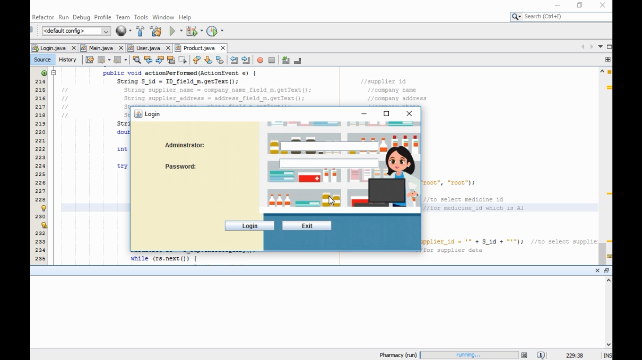

First of all we made a login form for the administrator for entering the information of login in to access the project to easily handle the stuff in the pharmacy.

1. **Main Form:**

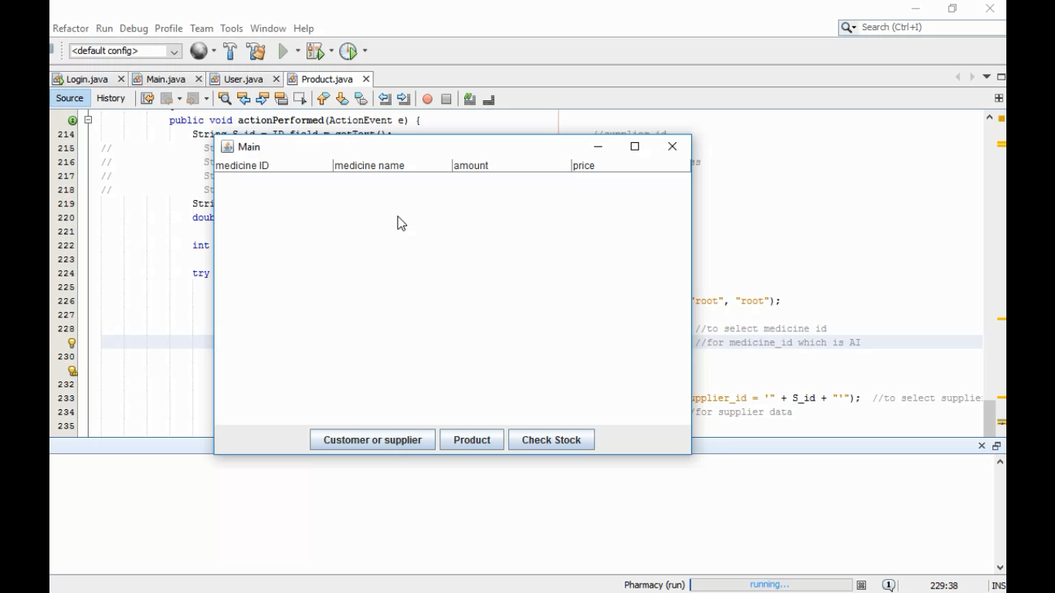

After accessing the project the administrator will work with the main form which has a 3 basics buttons that can simply managing all what we need to handle in the project, the three button called: Customer or Supplier button, Product button and Check Stock.

1. **Customer:**

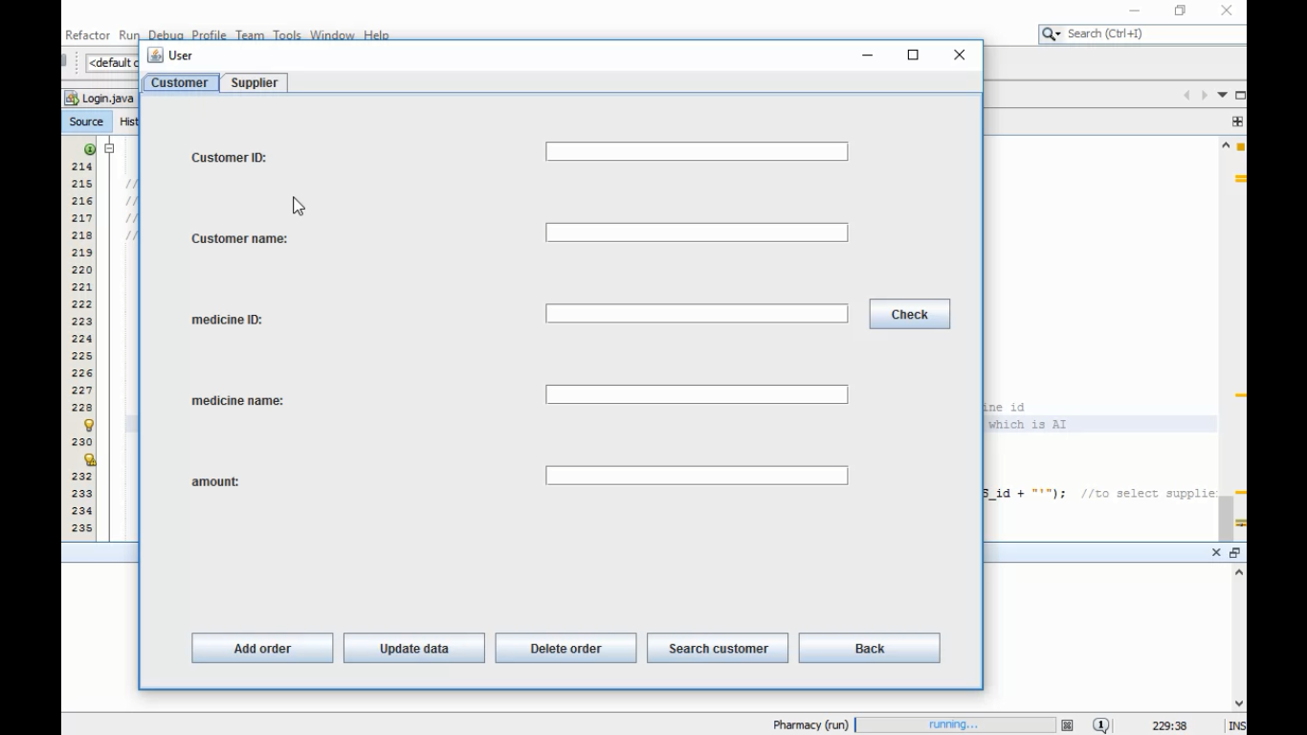

In the customer form, the administrator will have to deal with each textfileds to fill them with right information about each one of them and we will store the info we got from customer in our database to easily access it later and find our cool customers easily with their own stuff.

1. **Supplier**

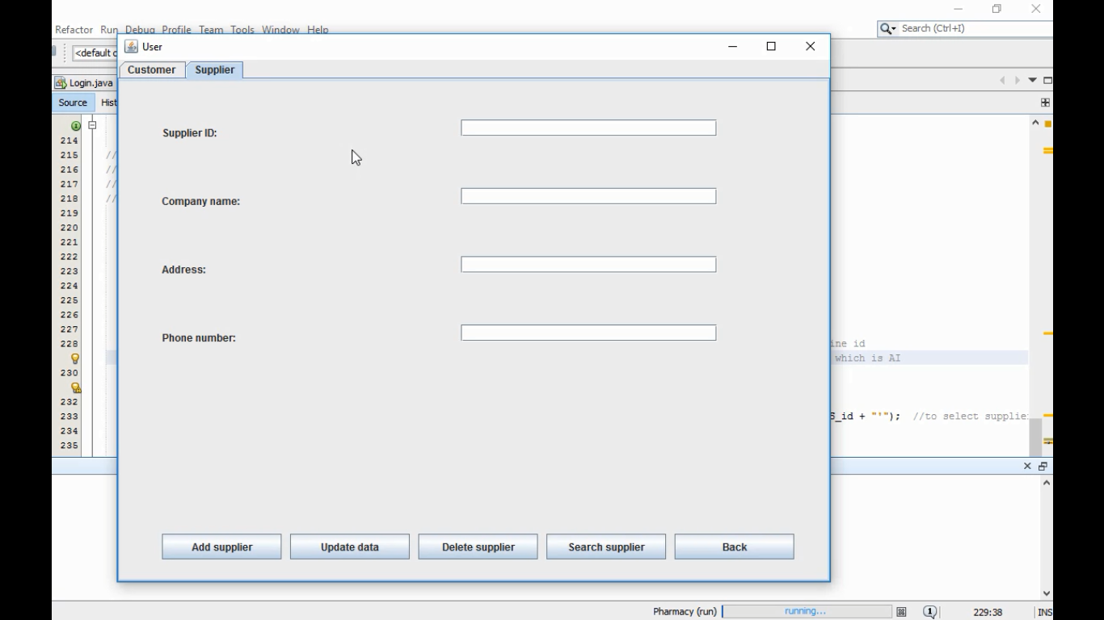

In the customer form, the administrator will have to deal with each textfileds to fill them with right information about each one of them and we will store the info we got from supplier in our database to easily access it later and find our cool suppliers easily with their own stuff.

1. **Product (manage form)**

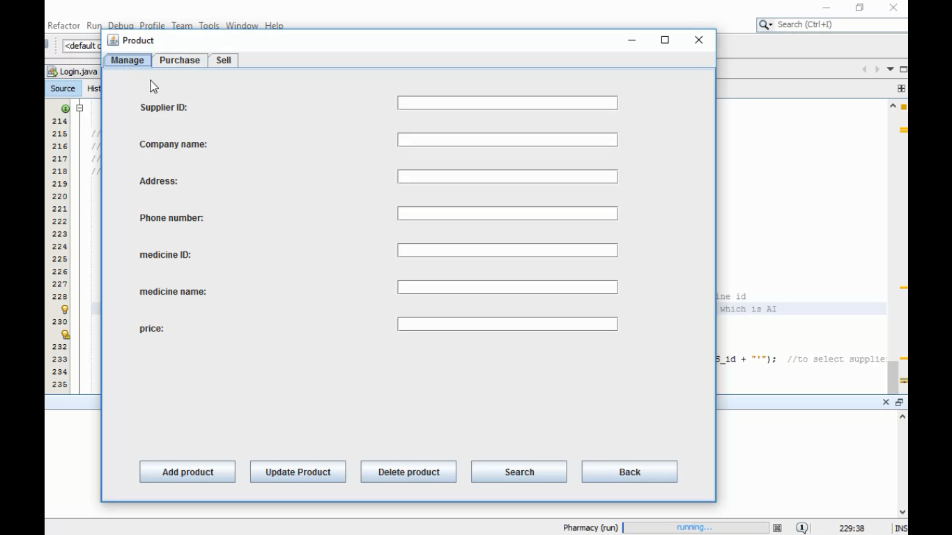

In the product form, we have 3 sections the first section called manage, in manage area we will fill them with the information we got from any suppliers and some of our customers, then we will store the data we got in our database we made a section for it there, we also add button to make our project easily for using and handling anything.

1. **Product (purchase form)**

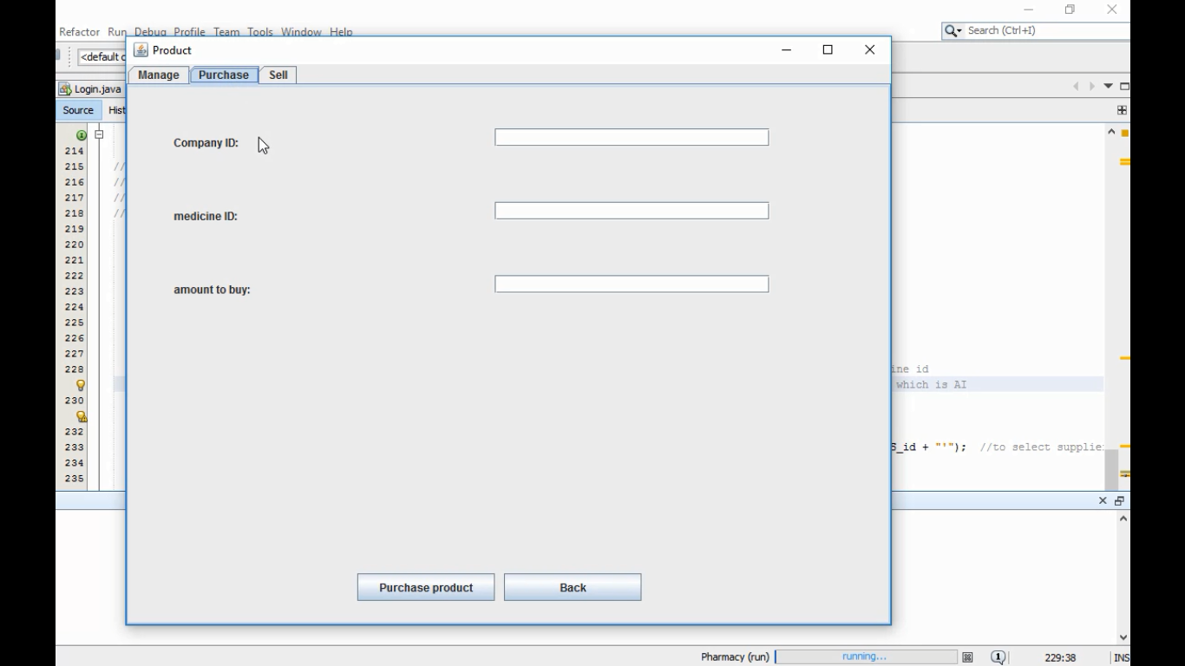

In the product form, we have 3 sections the second section called purchase, in purchase area we will fill them with the information we got from any suppliers and some of our customers, then we will store the data we got in our database we made a section for it there, we also add button to make our project easily for using and handling anything.

**7.Product (sell form)**

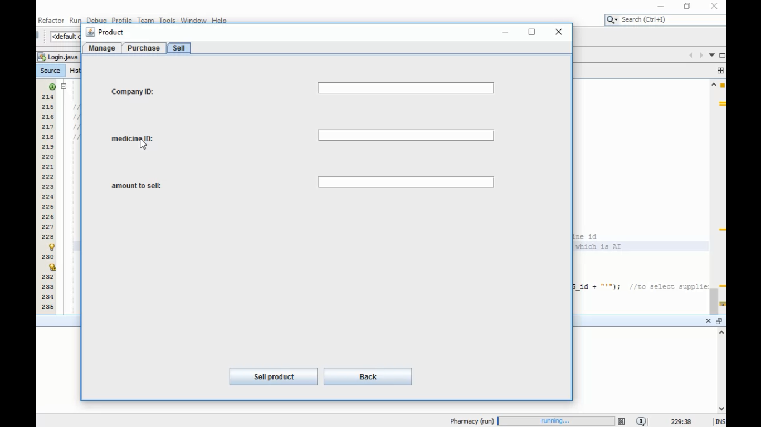

In the product form, we have 3 sections the last section called sell, in sell area we will fill them with the information we got from any suppliers and some of our customers, then we will store the data we got in our database we made a section for it there, we also add button to make our project easily for using and handling anything.

**Existing System:**

While in the existing system, it doesn’t have in built ability to look up database and work modules section and add new drugs upon confirmation of the admin. To store data to the database, one person have to look up the work and add data to populate database. Because of standalone system, no chances of using this system for multi user environment. Among all, the most important for any business process was not available such as daily logs report, not possible to make audit report and no functionality to prepare customized report as per business requirements.

**Proposed System:**

This new pharmacy management system is just like workflow software which can be treated as full version software which has generic modules to prevent underpayment that makes efficient business system. Its automatic batch processing system saves time and money for the user who will use this system through with excellent graphical user interface. Upon all, to meet real time environment working process, this system has automated durable medical equipment billing system. To make non stoppable development process, its full interaction checkup provides the flexibility of drug interaction and status, does checking, allergy checking report and medical reports, duplicate therapy and private patient messages.

**Pharmacy Structure:**

Software testing is the process of executing a program with the intention of finding errors in the code. It is the process of exercising or evaluating a system or system component by manual or by automatic means to verify that it satisfies specified requirements or to identify differences between expected and actual results.

The objective of testing is to show incorrectness and testing is considered to succeed when an error is detected. An error is a conceptual mistake made by either the programmer or the designer or a discrepancy between a computed value and a theoretically correct value. A fault is a specific manifestation of an error. An error may be cause of several faults. A failure is the inability of a system or component to perform its required function within the specified limits.

A failure may be produced when a fault is executed or exercised.

Other activities that are often associated with software are static analysis and dynamic analysis. Static analysis investigates the source code of software, looking for problems and gathering metrics without actually executing the code. Dynamic analysis looks at the behavior of software while it is executing, to provide information such as execution traces, timing profiles and test coverage information.

**Extensions:**

The system analysis phase is considered to be one of the most important phases in the system development life cycle. It is immensely important that the software developer make through study of the existing system. Thorough study of the system is made and need i.e. features that are critical to system success and users wants (i.e. features that would be good but not essential) are brought out. The study will enable the developer to know the intricacies of the existing system.

Requirement analysis is done in order to understand the problem which the S/W system is to solve e.g., the problem could be automating the existing manual system or developing a completely new automated system or a combination of the two. For large systems having a large number of features and

the need to perform many different tasks, understanding the requirement of the system is a major task. The emphasis in requirement analysis is on identifying what is needed from the system, and not how the system achieves its goal.

**Difficulties Encountered:**

1. Before making this application, we assumed that Pharmacy which had recently started its operation found it very difficult to handle their customers.
2. It was due to their great customer service and efficient handling of daily operations

that they customer base started growing and in a day, they started to handle lot of customer requests. The problem is that in manual pharmacy record keeping system excessive staff employment is required, extremely time consuming process is involved, inconveniences to both customers as well as to the manager.

1. Slowly & slowly the count of such customers started to grow very rapidly.

**Conclusion:**

We can hereby conclude that:

* The system effectively automated the functions involved in the processes being

handled manually before.

* The cost & benefit analysis shows that the system was quite successful in saving costs for the pharmacy & generate equivalently huge benefits
* The system is secure & scalable. The system design has been done keeping user-friendliness and efficiency in mind